Piano
Konstanze Eickhorst

Konstanze Eickhorst grew up in Bremen where she received recorder and piano lessons from the age of five. Aged eleven she was accepted by Karl-Heinz Kämmerling as a pupil of his piano class at the Hochschule für Musik und Theater in Hanover. He remained her most important mentor throughout her years of study. Konstanze Eickhorst also gained valuable insight from her work with Vlado Perlemuter in Paris.

Winning frst prizes at the “Clara Haskil” and “Geza Anda” international competitions served as a springboard for a successful career leading to engagements as a soloist with renowned orchestras and at illustrious festivals. She performs under the direction of conductors such as Christoph Eschenbach, Andrew Davis, Peter Schneider, Manfred Honeck and Ingo Metzmacher.
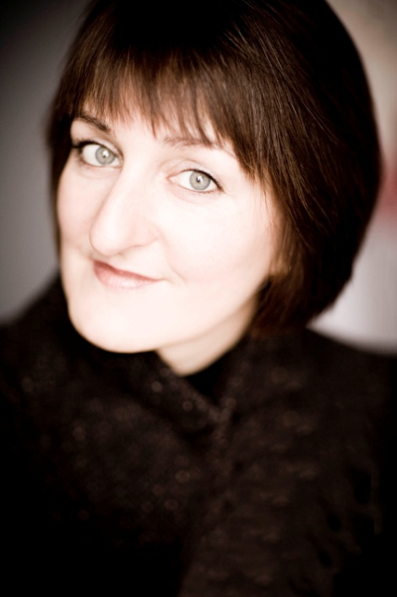
She discovered her passion for chamber music very early on. Konstanze Eickhorst is a member of the Linos Ensemble, which performs in various combinations of instruments from anything between two and nine. Several CD recordings exist with Konstanze Eickhorst as soloist or chamber musician. They display a broad repertoire and bear witness to her keenness to discover musical literature that is little known. On the release of the CD recording of the quintet for piano (left hand), clarinet and string trio in A major by Franz Schmidt she and the Linos Ensemble were awarded an ECHO Klassik. 2018 a further rarity, the piano quartet op. 16 by Arnold Krug, came out on cpo, and her Bach-solo recital with GENUIN will be released in March 2020.

At the age of 28 Konstanze Eickhorst was appointed professor at Hannover’s Hochschule and a few years later she extended her teaching to the Hochschule in Lübeck.

At the start of the 2016/17 Konstanze Eickhorst accepted a guest professorship at Kraków Musikhochschule. She is passionate about sharing and communicating her wide musical experience. She gives master classes for both piano and chamber music, and appears as a jury member at international competitions.

For further information:
www.konstanze-eickhorst.com

