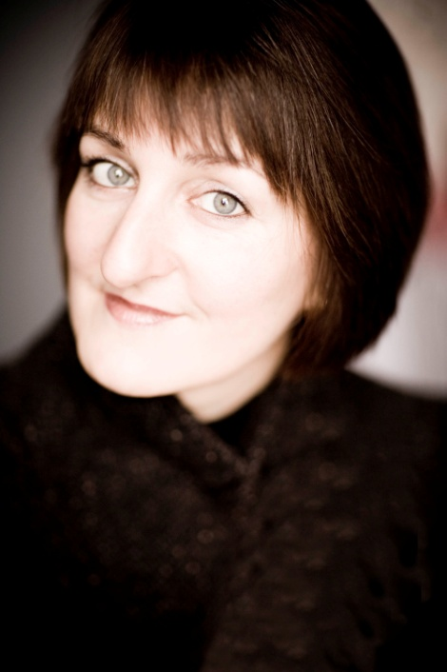

Piano
Konstanze Eickhorst

Describing the pianist Konstanze Eickhorst, the highly influential German music critic Joachim Kaiser named as her particular characteristics her immaculate mastery of technical matters and her intensity of expression. This opinion was shared by the judges at the Clara Haskil and Géza Anda Competitions, both of which nominated her for first prize. She won further accolades at the Bach Competition Toronto (in memoriam Glenn Gould) and of the Queen Elisabeth Competition in Belgium.

These successes marked the start of an international performing career which has taken her to the foremost musical centres, to the Montreux, Lucerne, Salzburg, Ravinia and Berlin Festivals, and also to collaboration with renowned conductors such as Christoph Eschenbach, Andrew Davis, Peter Schneider, Manfred Honeck and Ingo Metzmeyer. She was a student of Professor Karl-Heinz Kammerling in Hannover, and an equally important mentor was Vlado Perlemuter in Paris.

Konstanze Eickhorst is not easily classified: she is a pianist but also a chamber musician and a teacher. “These are the three pillars on which my musical life is based,” she said in a recent radio interview.

For her piano recitals she puts together brilliant programmes and stimulates wide interest with exciting discoveries of rarely-played works. She was one of the first women pianists to take a special interest in the solo works and songwriting of Clara Schumann, and she has also played a significant role in the rediscovery of the compositions of Louise Farrenc.

It was very early in her career that she discovered her passion for chamber music. She is a member of the Linos Ensemble, which performs in variable combinations of instruments ranging from duo to nonet. Numerous CD recordings exist with Konstanze Eickhorst as soloist and chamber musician; many of these are first recordings in collaboration with the CPO label. The Linos Ensemble’s CD production of Franz Schmitt’s Quintet in A major for piano left hand, clarinet and string trio received an ECHO Klassik award. A CD of solo works by JS Bach which appeared in 2020 under the GENUIN label was reviewed in Klassic heute: “Konstanze Eickhorst’s main pianistic aim in her Bach performances is evidently to shed more light.”

The Linos Ensemble’s two CDs of works by Louise Farrenc were followed in 2023 by a third, of which The Strad wrote: “During these performances Konstanze Eickhorst revels in the brilliance of Farrenc’s piano writing, and she masters the technical demands of the outer movements of Op.34 with bravura. In doing so she never overshadows her colleagues but makes sure that the string lines come clearly through the textures.” And her relish for discovering forgotten delights continues: in spring 2026 the ensemble will be joining CPO to record chamber music by the sadly short-lived English composer William Yeates Hurlstone (1879-1906) in a performance scheduled to go out on Deutschlandfunk [a German public-broadcasting radio station].

Alongside her performing activities Konstanze Eickhorst also sees it as her task to transmit her experience and expertise to the younger generation of pianists. In 1989 she took up her successful teaching career at the Hochschule fur Musik und Theater in Hannover as one of the youngest professors in the history of German music colleges, before being appointed to a similar post at the Lubeck Academy of Music. She has also been a guest professor in Kraków, is regularly invited to serve on the panel of judges at international piano competitions, and gives master classes both in Germany and abroad.

For further information: www.konstanze-eickhorst.com

